Work package 5: Relevant CLIC linac sub unit with beam.
(Construction and test with beam of one PETS structure with four CLIC accelerating structures.)

Motivation.
The International Linear Collider Technical Review Committee has listed “the test of a CLIC relevant linac subunit“ as a Ranking 2 task for the CLIC study.

CLIC linac sub unit.

The CLIC linac sub unit, shown in Fig. 1, consists of one Power Extraction and Transfer Structure (PETS) and four CLIC accelerating structures (HDS). The PETS generates 560 MW 30 GHz rf power by decelerating the 163 A drive beam, this power is transported to the HDS structures with a transfer efficiency of 95% so that the input power to each HDS is 130 MW.
The PETS structure is equipped with a special mechanism which enables the production of rf power to be turned OFF in the case of an rf breakdown in any one of the four HDS structures.
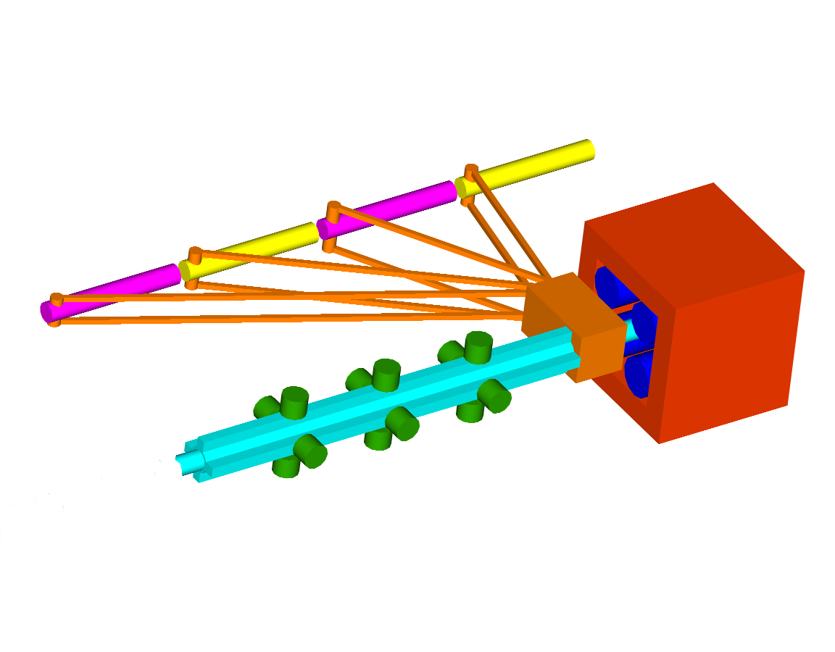
Figure 1. CLIC linac sub unit layout.

Work package description.

The requirement is for a fully-equipped test facility to enable the testing of a CLIC linac sub unit consisting of one CLIC PETS with ‘on/off’ option and 4 HDS structures with the nominal CLIC 30 GHz rf power and pulse length. Since the CTF3 drive beam is only 35 A instead of the 163 A CLIC beam, it will be necessary to use a booster PETS structure to “prime” the CLIC PETS to produce the full power. This booster PETS will produce 330 MW 30 GHz rf power which will be fed to the input of the nominal CLIC PETS. Although it is foreseen that the one PETS and four HDS structures required for this test will be provided by work-packages 7.1 and 7.2, it would be highly desirable to add fully-engineered pre-series prototypes of these structures to this work package and use these structures for the final test.

List of work package items.

- ‘On/Off’ CLIC PETS (CERN design)
- Four CLIC HDS accelerating structures (CERN design)
- Booster PETS
- High power waveguide distribution network and RF loads
- Vacuum system and girder
- RF and probe beam diagnostic networks

Work package expected resources.
.
- Manpower: 8 man years
- Budget: 1.5 MCHF

Work package schedule.

- Hardware manufacture and installation: end 2007
- Test stand operation: starting 2008

